Celebrating Appalachian Heritage:
An Event Proposal for an Appalachian Community Art Day

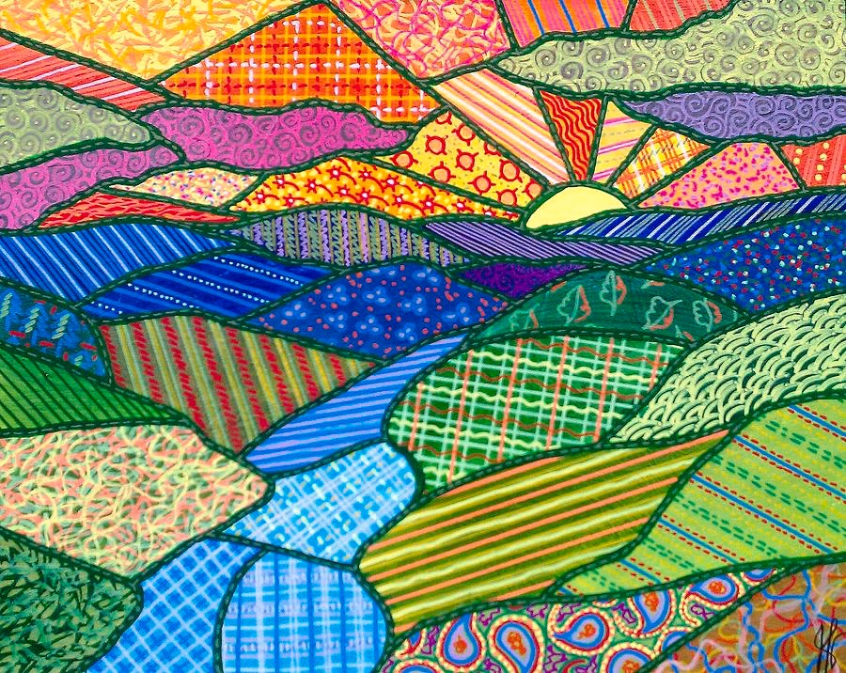
Image by Jim Harris, 2011

Morgan Wallace Gilbert
ARE 6641: Contemporary Issues in Art Education
Dr. Linda Fisher
Spring 2015

Living in Appalachia means experiencing a distinct culture unlike anything else in the world; proudly being the originators of things like bluegrass music and quilting must be cherished and celebrated. Nevertheless, negative stereotyping towards Appalachian tradition leads to disinterest in traditional methods and a “grass is greener” thinking in many Appalachian young adults. With the globalization of our technology driven world, traditions are becoming muddled and are disappearing. Helping a new generation of artists move the culture in the direction they see fit is only foreseeable if they have a foundation to work from. Hopefully, developing an interest and intrigue in traditional arts will in turn develop a notion of building upon traditional methods to create new innovations.
In Virginia, local history is taught as part of the curriculum only once in a child’s life, in the 4th grade history classroom. This is often a focus on their state history, with no information on local history or culture. As students grow, focus is often towards getting away from their own region. Students are encouraged to explore colleges, cultures, and histories that aren't their own before they even learn about where they came from. Teaching multiculturalism is such a priority in teacher education programs and professional development events, but there is never any focus on teaching a students’ own culture.
The visual arts classroom is a perfect venue to explore one’s own culture through history, expression, and aesthetics. We talk often about how in our world of cultural diversity, it is so important to teach our students about stereotypes and understanding other cultures. In the article, Guidelines for the Multicultural Art Classroom, teachers are suggested to “examine, confront, and correct the prejudices they may have toward gender, race, socioeconomic class, age, religion, ethnicity and mental and physical abilities” (Stuhr, Petrovich- Mwaniki, & Wasson, 1992, p. 19). Although this is very important, it often gets put in front of learning about students’ own culture. When studying cultures, cultural diversity comes hand in hand with teaching art history. Students explore artists of different background and nationalities and how that has affected their work. However, we often forget to look at how our own cultures affect how we look at and make art. I am very lucky to have grown up and now teach in a very culturally defined area of Appalachia. Although I have realized how unique and noteworthy the Appalachian culture is, my students don’t always agree. Seeing stereotypes of “hillbillies and hicks” representing their culture definitely does not seem cool to them, especially when moving away is a natural teenage response to their hometown. How, as art educators, do we find a way to make culture engaging for students?
Teaching traditional crafting techniques like quilting, weaving, pottery, and woodworking shows my students techniques their ancestors used to provide for their families when there weren’t Target and Amazon to instantly get anything they want. Learning these techniques are great, but does is really teach students about the necessity of making your own quilts or freezing in the cold night?
“It is often assumed that art is multicultural by virtue of its cultural diversity. By merely presenting exemplar of cultural products such as Egyptian Hieroglyphics, American Indian totem poles, and/or Australian bark paintings followed by the production of copies of these forms, many art educators are missing the point. Such tokenism not only trivializes the aesthetic production of all sociocultural groups, but, what is worse, it avoids confronting the real challenge of critically apprehending the meaning of the object, artist, process, in the sociocultural context. Further it fails to make legitimate links and contributions to the students’ lives in ways that are morally, ethically and cognitively sound. (Stuhr, 1992, p. 21)”
Do we do a disservice to the cultures we are teaching by only teaching technique? How do we learn ourselves how to accurately describe these cultures that we often don’t know much about ourselves? I think the very best way to teach culture is through immersion. To truly learn a new language, you have to immerse yourself in it. When exploring cultures in the art classroom, it is so important to source current professional artists or artisans who can help convey the culture in an accurate manner.
Curators of museums are ultimately the ones who decides what and how cultural objects are shown. Even in my own culture, that of Appalachia, there is a tendency to show the “traditional” as all that defines the culture. Representations of quilts and corn cob pipes define visual representations of the culture, dominating most exhibits of “Appalachian” art. However, contemporary Appalachian artists are taking these traditional techniques and building them into a “contemporary craft” movement pioneered by outstanding fine art-based craft schools like Penland School of Craft. Though we live in a post-colonial world that supposedly welcomes diversity, there will always be stereotypes and inaccurate representations of cultures. The only way to ultimately take steps away from these misrepresentations of cultures are to utilize experts in these areas and use our resources to explore them through travel.
Our technological world has begun to create an interesting offshoot through the use of websites such as Pinterest or Etsy by creating an avenue to teach and market handmade goods. However, learning from a YouTube video never compares to having conversations with professionals who are willing to share tricks and techniques. Creating a dialogue between the older Appalachian artisans and the new DIY’ers generation has the possibility of meshing the use of technology with traditional techniques of art making.

Action Plan
Creating a community art event that highlights local artists, musicians and creators could bring awareness of arts in the region, education of Appalachian craft techniques, and develop arts advocacy in the community. There are many tourism and culture associations in the Southwest Virginia area that would be valuable to create partnerships with in creating an Appalachian Art Day. The most notable one would be ‘Round the Mountain: Southwest Virginia’s Artisan Network based in Abingdon, Virginia. ’Round the Mountain: Southwest Virginia's Artisan Network is a non-profit organization whose mission is to promote sustainable economic development of the region's communities by assisting local artisans with marketing, educational, and entrepreneurial opportunities (2014. Creating a partnership with ‘Round the Mountain would mean utilizing their artisan networking to contact artisan and invite them to set up and demonstrate their work for the Appalachian Arts Day. Based on scheduling and feedback, it would be ideal to have scheduled demonstrations throughout the day, so community members could schedule which artisans they would like to see. Artisans would be encouraged to spend time throughout the day set up to both sell their wares and communicate one-on-one with community members and students.
In addition to visual artisans, integrating other aspects of Appalachian culture would add depth and interest to the event. Inviting traditional Bluegrass musicians would be possible through the sister organization of ‘Round the Mountain, The Crooked Road. Highlighting student achievements in music would be possible through possible small ensemble groups in both traditional and non-traditional styles.
Venue requirements for such an even would require a large area such as a parking lot or conference center. An outdoor event would be preferable, due to the strong connection to nature that is integral to the Appalachian culture. A possible venue would be a local farmer’s market during the summer to additionally highlight local farmers and chefs.
Creating this event as a community event, rather than a specifically school-wide event is integral to creating a dialogue within parents and students, administration and teachers, and community members. Although students see things the high school art department is doing on a daily basis, many of the great achievements stay within the school walls. Involving the community within the event would allow for some visualization of what the students talk about and learn about, and open it up to anyone. High school art department, specifically those members of the National Art Honor Society would help facilitate and plan the event set up, events, and break down.
Art is one of the defining factors to looking at our past cultures and developing new cultural traditions for the future. In the midst of our globalizing world, we are losing track of our immediate world. It is integral to take steps to ensure our cultural traditions and expand them into the future.
“The first step - especially for young people with energy and drive and talent, but not money - the first step to controlling your world is to control your culture. To model and demonstrate the kind of world you demand to live in. To write the books. Make the music. Shoot the films. Paint the art.” ― Chuck Palahniuk

References
Faith Ringgold. (n.d.). Retrieved March 29, 2015, from
http://www.faithringgold.com/ringgold/default.htm

K-12 Resources - Appalachian Studies Association. (n.d.). Retrieved March 29, 2015, from http://appalachianstudies.org/resources/k12-2.php

Oakley, L. (Ed.). (n.d.). Teaching Tennessee History: Lesson Plans for the Classroom Volume IV. East Tennessee Historical Institute. Retrieved March 29, 2015, from http://www.volunteervoices.org/lesson-plans/ETHS_Vol4_Appalachia_Lesson_Plans.pdf

Pitts, Valerie Renee, "Teaching the Arts through the Appalachian Culture: a Proposal for a High-School Class." (2001). Electronic Theses and Dissertations. Paper 27. http://dc.etsu.edu/etd/27

'Round the Mountain. (2014). Retrieved March 29, 2015, from https://www.myswva.org/rtm
Stuhr, P. L., Petrovich-Mwaniki, L., & Wasson, R. (1992). Curriculum guidelines for the multicultural art classroom. Art Education, 45(1), 16-24.

The Foxfire Approach. (n.d.). Retrieved March 29, 2015, from https://www.foxfire.org/teaching.html

Walker, H. (2001). Interviewing Local Artists: A Curriculum Resource in Art Teaching. Studies in Art Education, 42(3), 249-265. Retrieved March 29, 2015, from http:// www.jstor.org/stable/1321040

